Turtle Graphics with Python
Visit https://repl.it/ and search for “turtle” and select “Python with Turtle”. You can skip the registration, it is not necessary to create an account.

Prepare the IDE
First you have to import the library to start. Just try the following code in order to obtain the graphic:
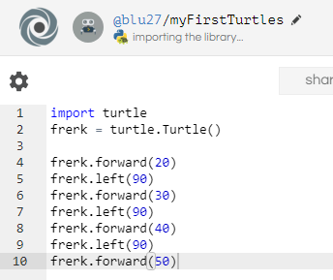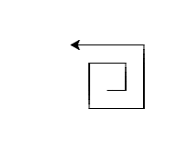

Exercise 1
Use the methods forward(), right() and left() to draw the following figures:
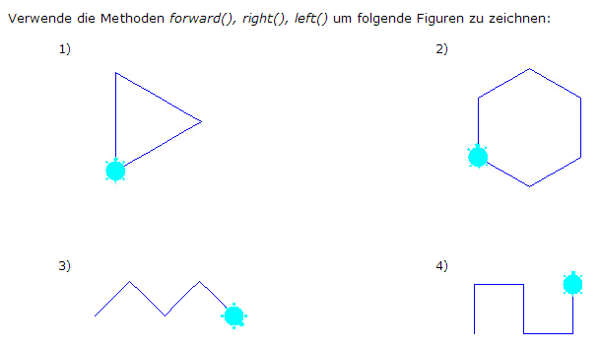

Tutorial
Follow https://opentechschool.github.io/python-beginners/en/index.html in order to learn about variables and loops…

Exercise 2: loops
Use while – loops to generate a spiral. The syntax of a while-loop is
x=1
while x < 10:
frerk.forward(5*x)
x = x + 1
In this example you have to add the method to turn left…
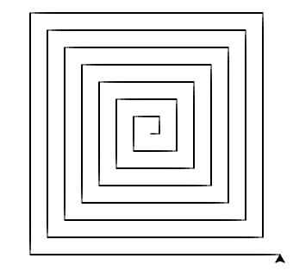

Exercise 3: nested loops
Use nested while – loops to generate a spiral of squares:
The inner loop generates one square. The outer loop repeats the inner loop eg 10 times:
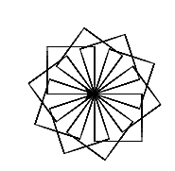

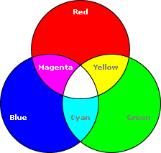
Exercise 4: Colour
All colours on your screen can be mixed out of the three basic colours red, green and blue.
Bring some colour in your turtles life by using.
frerk.pencolor((255, 0, 100))
For each colour you can choose values between 0 and 255…

How many different colours are available?

Exercise 5: Random numbers
You can generate random numbers by
x = random.randint(0,255)
Use this information to change the pen’s colour randomly and draw a colourful spiral (or whatever you want).

Exercise 6: User defined functions
Follow the instructions on
https://opentechschool.github.io/python-beginners/en/functions.html in order to create your own functions.
- Create a function that writes the first letter of your name, e.g. “P”.
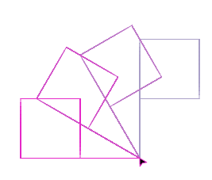
- Play around with this letter, e.g. with colours and or using loops

Exercise 7: User defined functions with parameter
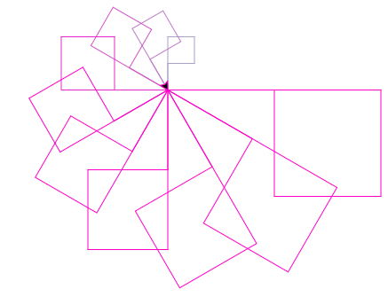
If you still have time, try to resize the letter from the previous exercise using a parameter in the function (see https://opentechschool.github.io/python-beginners/en/functions_parameters.html#introduction) to get a result like

Solutions

Exercise 2:
import turtle
frerk = turtle.Turtle()

x=1
while x < 30:
frerk.forward(10*x)
frerk.left(90)
x += 1

Exercise 3
import turtle
frerk = turtle.Turtle()
x=1
while x<11:
z = 0
while z < 4:
frerk.forward(50)
frerk.right(90)
z +=1
frerk.right(36)
x += 1

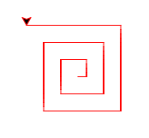
Exercise 4:
import turtle
frerk = turtle.Turtle()
frerk.pencolor((255, 0, 0))
x=1
while x < 12:
frerk.forward(10*x)
frerk.left(90)
x += 1
How many colours are available?
For each colour r, g and b you have 256 = 2⁸ different states.
So you can mix $256∙256∙256=2^{8}∙2^{8}∙2^{8}=2^{24}≈16,800,000$ different colours .

Exercise 5:
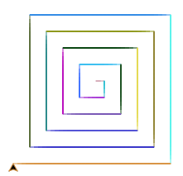
import turtle
import random
sampo = turtle.Turtle()

x = 1
while x<20:
r = random.randint(0,255)
g = random.randint(0,255)
b = random.randint(0,255)
sampo.pencolor((r, g, b))
sampo.forward(10*x)
sampo.right(90)
x += 1

Exercise 6:
import turtle
frerk = turtle.Turtle()

def letterP():
frerk.left(90)
frerk.forward(150)
frerk.right(90)
frerk.forward(75)
frerk.right(90)
frerk.forward(75)
frerk.right(90)
frerk.forward(75)
frerk.left(90)
frerk.forward(75)
frerk.left(90)

x = 1
while x < 5:
frerk.pencolor((150+20*x, 200-40*x, 200))
letterP()
frerk.left(30)
x = x +1

Exercise 7:

import turtle
frerk = turtle.Turtle()

frerk.speed(0)

def letterP(length):
frerk.left(90)
frerk.forward(2*length)
frerk.right(90)
frerk.forward(length)
frerk.right(90)
frerk.forward(length)
frerk.right(90)
frerk.forward(length)
frerk.left(90)
frerk.forward(length)
frerk.left(90)

x = 1
while x < 11:
frerk.pencolor((150+20*x, 200-40*x, 200))
letterP(20+10*x)
frerk.left(30)
x = x +1

