An introduction into Arduino programming

1: the Arduino Uno board
https://www.youtube.com/watch?v=09zfRaLEasY
- How many digital ports are available?
- How many analog ports are available?
- What’s the difference between both ports?

3: Getting used to the IDE
https://www.youtube.com/watch?v=YDkdVZ7e3OY
- Where do you find the information in which line your cursor is?
- What means IDE? If you do not know ask google ;-)

4: Syntax
https://www.youtube.com/watch?v=AJkEQ9t4WfY
- How can you insert comments into your source code?
- What is the difference between the two methods “setup” and “loop”?

5: An introduction into variables:
www.youtube.com/watch?v=QNTaQ5qjniE&t
Which Arduino datatypes were mentioned and what can you store in them?
- Go to the Arduino reference https://www.arduino.cc/reference/en/ and look for the datatype “boolean”. What kind of values can you store in variables from the datatype boolean?
- Which of the following variables are declared and initialised in the correct way?
int red_led = 5; int redLED = 5; int redLed = 5; int RedLed = 5;
- What is the difference between declaring and initialising a variable?

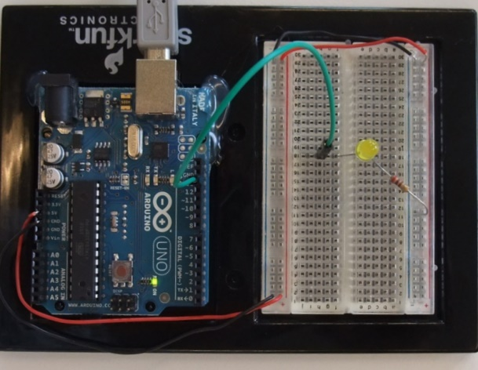
6a: Blinking LED
https://www.youtube.com/watch?v=33sNhlekRV8&
Use your breadboard to build the following circuit and use the code from Examples -> Basics -> Blink in order to let the LED blink.
- Decrease the delay in order to get a higher blinking frequency. Can you calculate the frequency when your eyes are no more able to distinguish the flickering?

6b: Traffic light
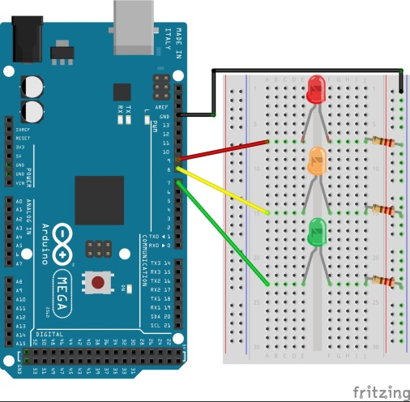
Modify the “blink” program to realise a traffic light.
Remember how the breadboard is connected internally:
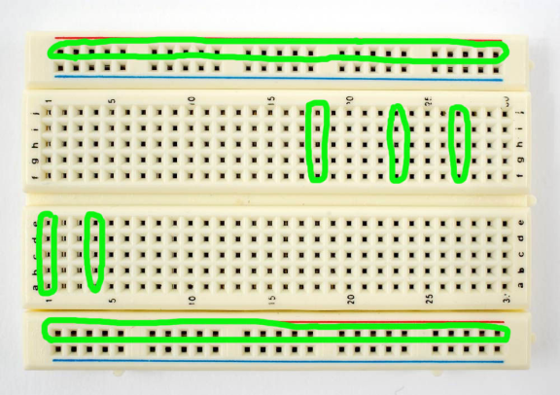

7: Read values and print data on the computer’s screen
https://www.youtube.com/watch?v=CIrN2CaO6bo
Build the following circuit (you can also use a digital port as INPUT) and detect the state of the button (pressed or not). Print the state using the serial monitor.
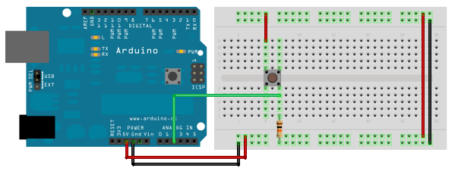
- Now insert a cable into your INPUT pin and play around with it while you are observing the detected value. What happens with the value from time to time?

8: Read “analog” values
www.youtube.com/watch?v=CPMQSXrsaO8&t
Build one of the following circuit using a potentiometer or an LDR (light dependent resistor), read the value and print it using Serial.print(…).
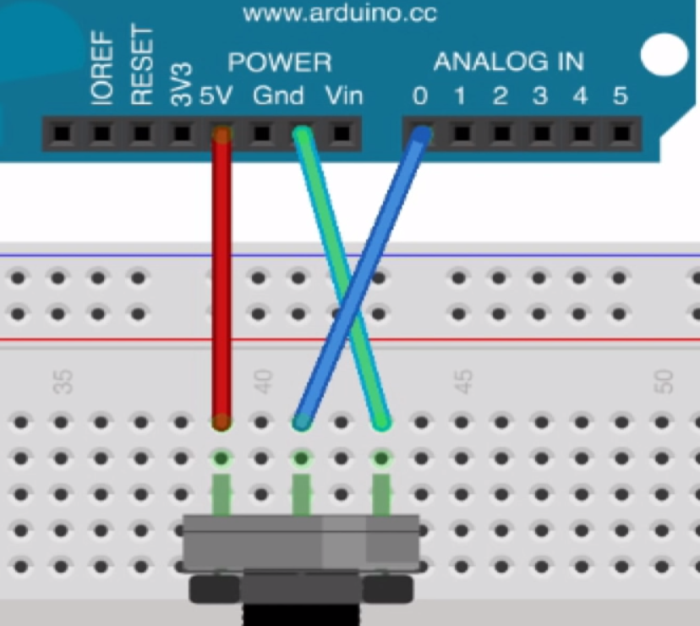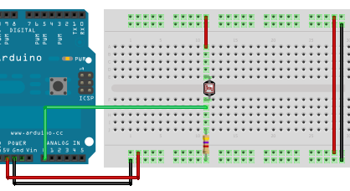
- Can you imagine how a potentiometer works?
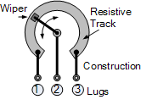
And here’s the idea behind both circuits (the same way you can also measure temperatures using NTC resistors (ask your teacher for one)):

- What is the maximum range of the values of an analog port?
- Optional idea for a project: the darker it is the brighter a light shall shine. Use an LED and an LDR.
- Optional: Measure a voltage using AnalogRead(): https://www.youtube.com/watch?v=_H16GYL08Ik
Congratulations, well done so far!

9: AnalogWrite (PWM – pulse with modulation)
Watch https://www.youtube.com/watch?v=wpTqiEcHwwQ and let a LED “fade”.
- Explain PWM: What does a 50% duty cycle mean?
- Can you explain the operators “= =” and “| |”?

