Loops with While and For

Goals:
Using a transistor to amplify the current.

Parts:
- BD437 transistor, 100 Ω resistor
- Optional: potentiometer
- Speaker or buzzer

Circuit:
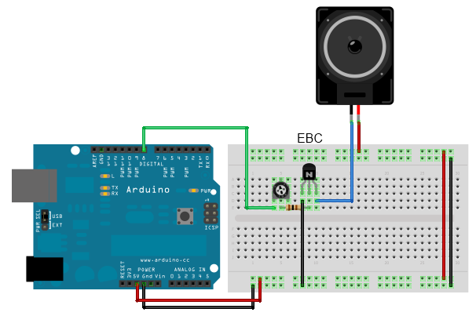

Exercises:
- Build the circuit as shown above.
- Toggle the port which goes to “B”. Use different frequencies for toggling.

Sourcecode:

