Light depending resistor

Goal:
The brightness of the LED shall increase if it is getting darker in the room.
First step: use analogWrite() to adjust the brightness of the LED.
Second step: use map() to convert the 10-bit value that you got from analogRead() into a 8-bit value which is necessary for analogWrite().

Parts:
- LED, 330 Ω resistor
- LDR, 10 kΩ resistor

Circuit:

Sourcecode:
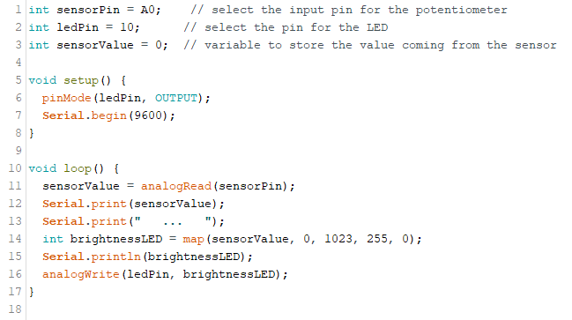
Attention: you have to adjust the values inside the map()-function according to your measured values.

